**UML Diagrams for Travel And Tourism Management System**

**1.Flowchart:**

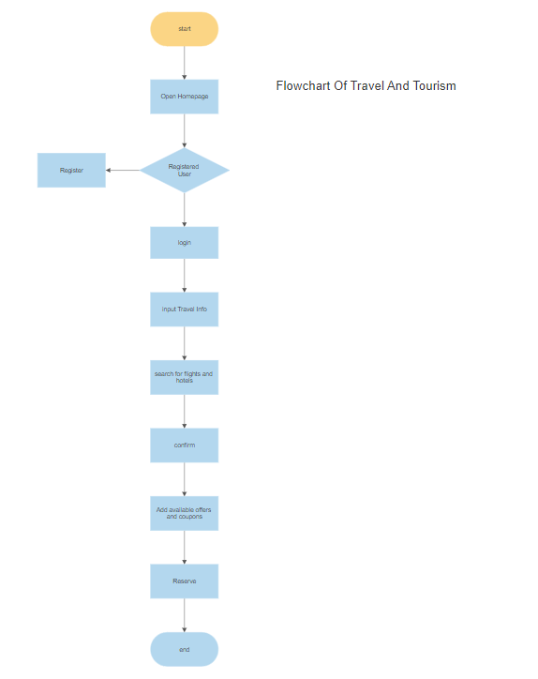

**2.ER Diagram:**

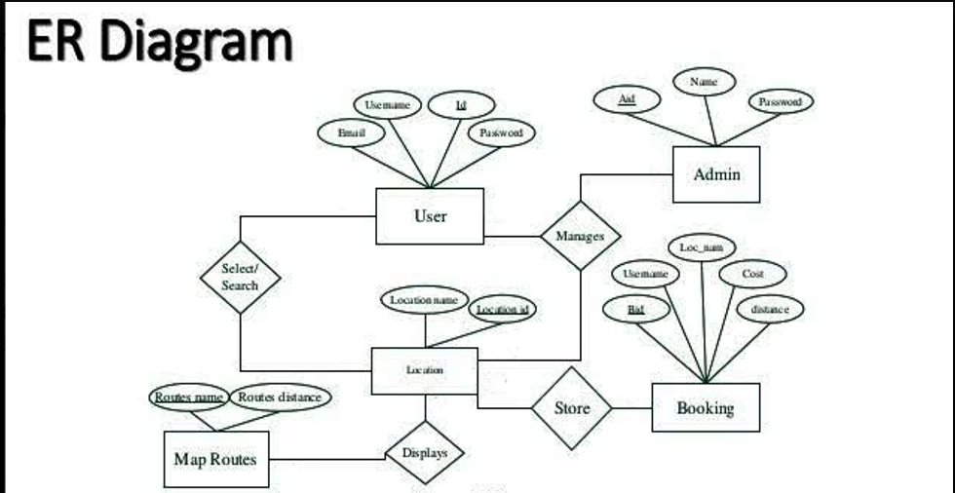

**3.Class Diagram:**

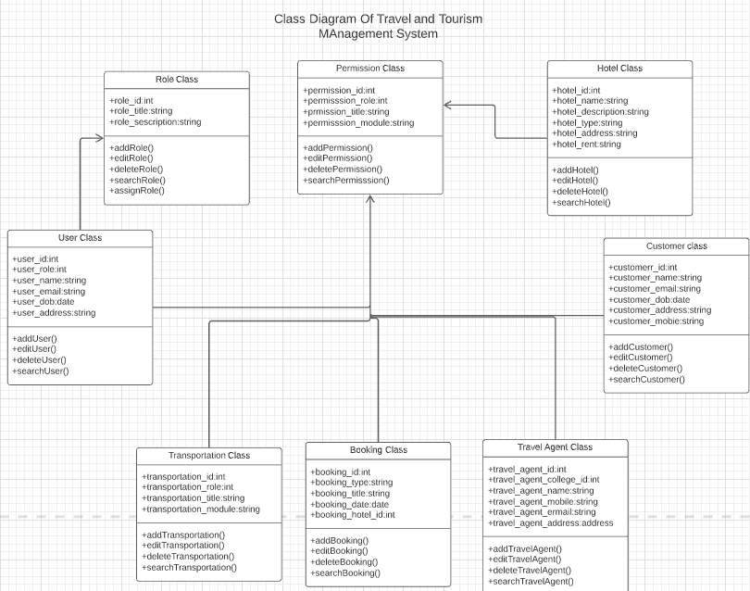

**4.Activity Diagram:**

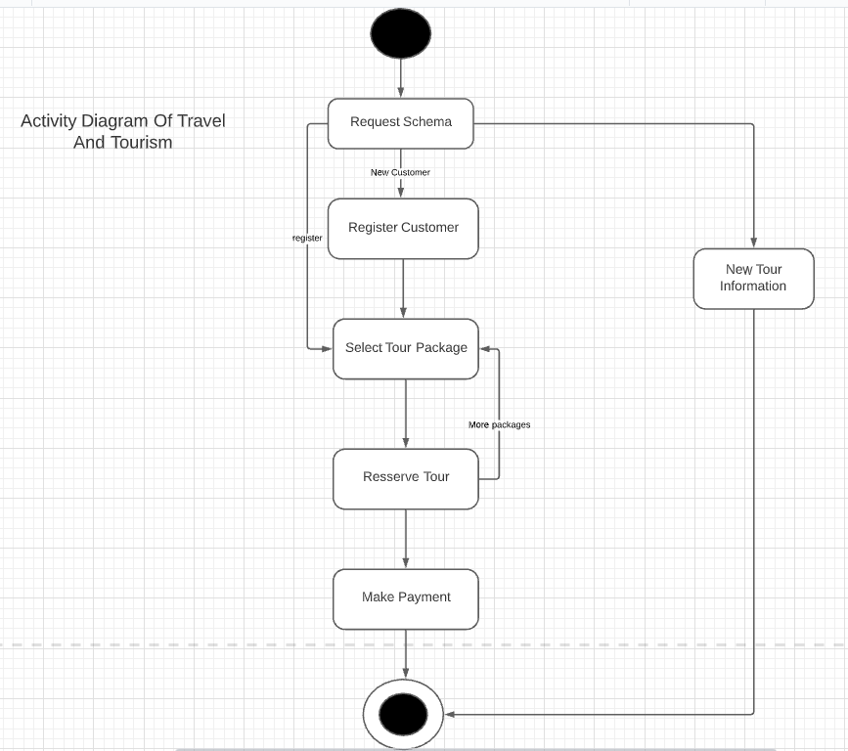

**5.Usecase:**

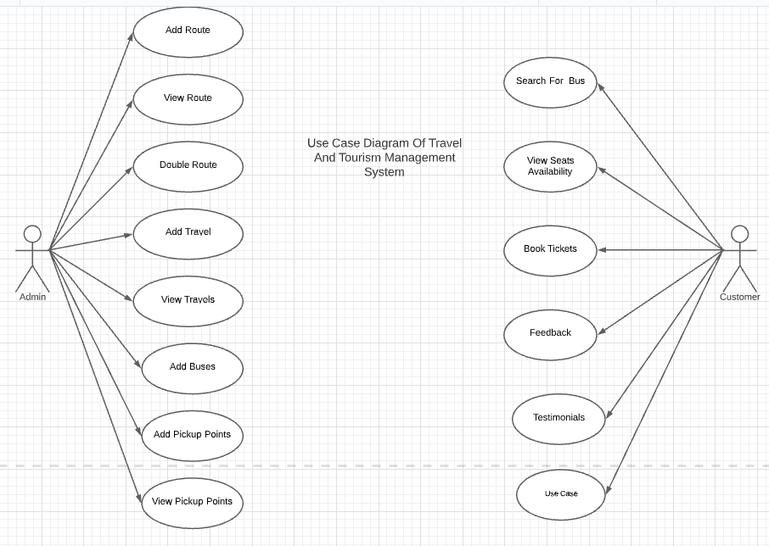

**6.Sequence Diagram:**

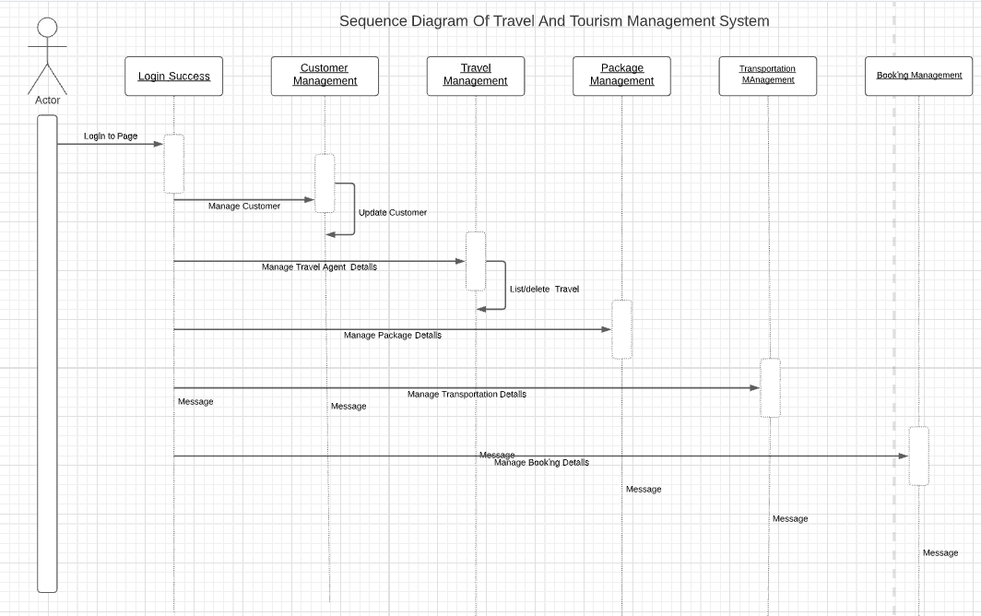

**7.Zero Level DFD:**

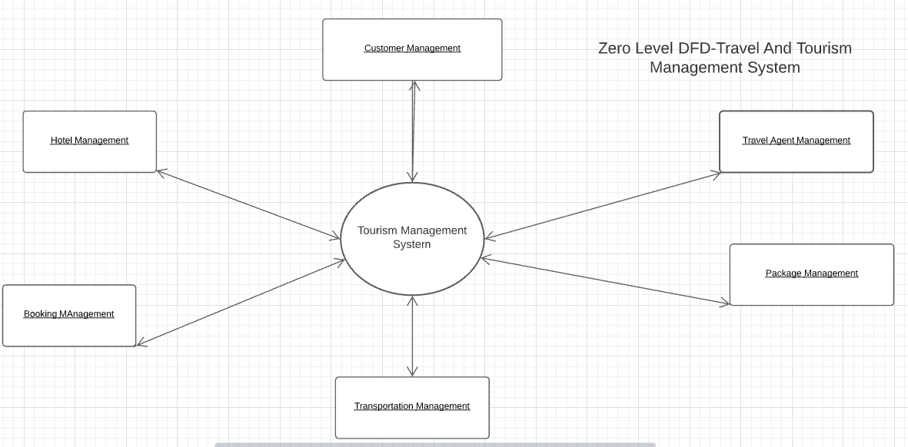

**8.First Level DFD:**

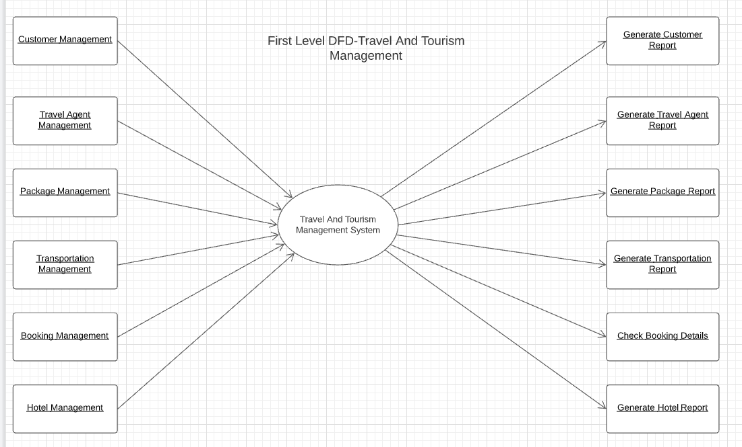

**9.Second Level DFD:**

